Adobe Photoshop CS5 Chapter 4 Test Notes

1. There are 2 basic methods of selection.

2. Combining selections from different images is called compositing.

3. Other Photoshop images, royalty-free images, and pictures from a digital camera may be legal and legitimate sources of artwork.

4. Selection tools are located in the tools panel.

5. Photoshop selection tools are used for learning the different selection options, evaluating the edges of images that can be used to isolate objects, and evaluating color as a way to isolate objects.

6. If the snap feature is enabled, as you drag an object toward a guide, and the object will be pulled toward the guide.

7. The feather setting blurs the area between the selection and the surrounding pixels.

8. You can temporarily change any selected tool into the Move tool by pressing and holding [Ctrl] (Win) or [command] (Mac).

9. To slightly enlarge a marquee you can use the grow command on the Select menu.

10. When the Magic Wand tool is selected the contiguous check box on the Options bar lets you select pixels that are next to one another.

11. When the Magic Wand tool is selected, the Options bar does not include a tolerance check box.

12. The Color Range command is located on the select menu.

13. The healing brush tool/command lets you fix imperfections in an image.

14. A 15 pixels setting should create a nice fade in a vignette.

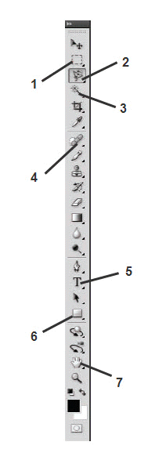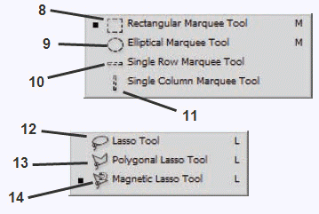

15. Item 1 in the figure above is used to create a rectangular selection.

16. Item 2 in the figure above is used to create a selection that snaps to an edge of an object.

17. Item 11 in the figure above is used to create a 1-pixel wide column selection.

18. Item 9 in the figure above is used to create an elliptical selection.

19. Item 12 in the figure above is used to create a freehand selection.

20. The figure above represents the options for the magnetic lasso tool.

Case 1

Adam’s father is a big fan of both Elvis and Steve Martin. On a whim, Adam searched the Web to find a photo of the two of them together, but found that no such photo was ever taken. He did, however, find several pictures of each performer. Adam decided that his father would appreciate it if he used his Photoshop knowledge to put Elvis and Steve Martin together in one picture.

21. The photo of Elvis that Adam decides to use is very crisp and clear. The magnetic lasso tool would be the best choice for selecting the King.

22. Adam is having a difficult time getting Elvis to line up correctly with Steve Martin. Smart Guides might help.

23. Adam wants it to appear as if the two men are looking at each other, but Steve Martin is facing the wrong direction and there isn’t room on that side of the photo to place Elvis. He can click Edit on the Application bar, point to Transform, and click Flip Horizontal.

24. Adam would use the Healing Brush tool for Elvis’ small smear of peanut butter on his cheek which Adam wants to erase.

Case 2

Franklin is having a hard time getting the elements of his project to line up. He decides that he had better use guides to simplify things.

25. Using guides has proven difficult because the colors in the project are very close to the color of the guide lines and it all just seems to blend together. Franklin would solve this by double-clicking a guide which will open a Preferences dialog box, where he can choose a more contrasting color.

